CRIME MONITORING CELL HOME DEPARTMENT
SINDH PROVINCE GOVERNMENT OF SINDH
DISTRICT JACOBABAD

S.NO | NAME OF NGO | NO AND REGISTRED DATE | ADDRES OF NGO | NAME OF OFFICE BEAREAR
 | Peace by youth welfare organization | Do/sw/cdd/jcd/va-143  Dated 11-07-2011 | Behind royal college first family line Jacobabad | Mr.Nisar ahmed
 | Shifa welfare association | Do/sw/cdd/jcd/va-259  Dated 29-01-2015 | Behind royal college first family line Jacobabad | Mrs murad jan brohi
 | Indus participatory development organization | Do/sw/cdd/jcd/va-248  Dated 30-10-2013 | Apposite gul imam bargah per  bukhari road jacobabad | Mr.Ghulam Muhammad soomro
 | Pakistan human best health organization | Do/sw/jcd/va-93  Dated 04-11-2009 | Mch center thull | Mrs. bushra aarain
 | Women children welfare association | Do/sw/jcd/va-256  Dated 29-04-2014 | Afzal khan khoso road  jacobabad | Mr.abdul rasheed khoso
 | Women empowerment association | Do/sw/jcd/va-246  Dated 01-10-2013 | Danger muhalla | Mrs. khalida parveen soomro
 | Insan dost welfare association | Do/sw/jcd/va-91  Dated 17-05-2009 | Garhi khairo | Mr.israr ali khoso
 | Youth action for Pakistan organization jacobabad | Do/sw/jcd/va-57  Dated 20-10-2005 | Behind royal college  first family line Jacobabad | Mr.liaqat ali
 | Human empowerment & development orgnaization | Do /sw/jcd/va-261  Dated 12-05-2015 | Muhalla Jafraabad  Jacobabad | Mr.iqbal ahmed
 | Mehran social forum | Do/sw/jcd/va-110  Dated 28-12-2010 | Baldiya shopping center  Jacobabad | Mr.abdul hayee soomro
 | Citizen welfare forum | Do/sw/jcd/va-101 | Mocha muhalaa thull | Mr.raja Muhammad farooq
 | Sindh education and welfare development | Do/sw/jcd/va-250 | Afzal khan khoso road  jacobabad | Mr.majid ahmed channa
 | Friends development association | Do/sw/jcd/va-112  Dated 26-03-2011 | Thul | Mr.mukhtiar ahmed mahar
 | Community development network organization | Do/sw/jcd/va-278 | Near mairaj hotel  Jacobabad | Mr.muhammad muslim odhano
 | Community advanced and support welfare association | Do/sw/jcd/va-119  Dated 11-05-2011 | First family line raifal naka  jacobabad | Mr.tariq ali chandio
 | Khushal sindh welfare association | Do/sw/jcd/va-252  Dated 08-04-2014 | First family line | Mr.asghar ali soomro
 | Muhammad umar kalwar | Do/sw/jcd/va-258  Dated 20-05-2014 | Ghribabad Jacobabad | Mr.javed umar kalwar
 | Human rights welfare organization | Do/sw/jcd/va-92  Dated 12-10-2009 | Kashi ram pul Jacobabad | Mr.hamadullah ansari
 | Journalist welfare association | Do/sw/jcd/va-220  Dated 04-11-2011 | Vill.ahmed mian soomro | Mr.hakim ali arri
 | Late rasheed ahmed memorial organization | Do/sw/jcd/va-29  Dated 03-12-2003 | Thull | Mr.ali gohar
 | Faryad childs & women welfare organization | Do/sw/jcd/va-245  Dated 05-09-2013 | M sharif street jacobabad | Mrs.sofia sarfaraz
 | Daudpota welfare organization | Do/sw/jcd/va-146  Dated 11-07-2011 | Water supply road thull | Mr.imdad ali
 | Childs protection welfare organization | Do/sw/jcd/va-253  Dated 29-04-2014 | Khoso muhalla thull | Mr. shah jahan
 | Taluqa press club | Do/sw/jcd/va-034  Dated 26-05-2014 | Thull | Mr.faiz Muhammad
 | Ithad friends welfare forum and national development | Do/sw/jcd/va-244  Dated 25-06-2013 | Gharibabad muhalla  jacobabad | Mr.wazir ali sarki
 | Patient welfare association | Do/sw/jcd/va-247  Dated 28-10-2013 | Civil hospital  Jacobabad | Mr.dr karim bux qasmi
 | Community development foundation | Do/sw/jcd/va-55  Dated 23-08-2005 | Near tcf school  jacobabad | Mr.muhammad jaan odhano
 | Human hope welfare association | Do/sw/jcd/va-89  Dated 29-01-2009 | Christian colony  Jacobabad | Mr.asif ali bhatti
 | Al dua welfare association | Do/sw/jcd/va-98  Dated 10-02-2010 | Family line | Mr.zafar ali
 | Bright women welfare association | Do/sw/jcd/va-249  Dated 27-01-2014 | Jatt muhalla  Jacobabad | Mrs.humera shah
 | madiha khawateen o itfal association | Do/sw/jcd/va-42  Dated 04-01-2005 | Near post office  jacobabad | Mrs.qamar bano
 | sindh rural development program | Do/sw/jcd/va-43  Dated 28-02-2005 | Garhi khairo | Mr.akbar umrani
 | Jeay latif art & welfare organization | Do/sw/jcd/va-138  Dted 30-06-2001 | Thull | Mr.abdul haq azad
 | Patient welfare society | Ad /sw/sukk/va-55  Dated 17-04-1985 | Thull | Mr.abdul karim mughal
 | Disable rights development organization | Do /sw/jcd/va-96  Dated 18-11-2009 | Special force road jacobabad | Mr.abdul hafeez jatoi
 | Prisoners & poor welfare foundation | Do/sw/jcd/va-84  Dated 28-01-2008 | Near gadai library jacobabad | Mr.advo-abdul jababr lashari
 | Deaf and dumb welfare association | Do/sw/jcd/va-54  Dated 13-07-2005 | Thull | Mr.aijaz ali
 | Al shahbaz welfare association | Dd/sw/lrk/va-315  Dated | Station road thull | Mr.nazeer ahmed bhatti
 | Savera development organization | Do/sw/jcd/va-260  Dated 23-02-2015 | Garhi khairo | Mr.ali hyder
 | Helpers welfare association | Do/sw/jcd/va-251  Dated 17-03-2014 | Thull | Mr.zahoor ahmed
 | Human friends welfare association | Fdd/sw/lrk/99/va-301  Dated 05-05-1999 | Thull | Mr.mukhiar ahmed noonari
 | Baptist Christian development organization | Do/sw/jcd/va-102  Dated 15-07-2010 | Chirst church quetta road Jacobabad | Mr.paster yousif maseeh
 | Kareem Gadai Academy Abdul welfare Association | Do/Sw/jcd/Va-87  Dated 23-05-2008 | Near Gadai Library Jacobabad | Mr. Sikander Khoso
 | Hamdarad development foundation | Do/sw/jcd/va-99  Dated 01-03-2010 | Thull | Mr.rab nawaz
 | Late shaheed shah nawaz memorial association | No /sw/lrk/294/  Dated 12-02-1999 | Thull | Mr.wafadar sundrani

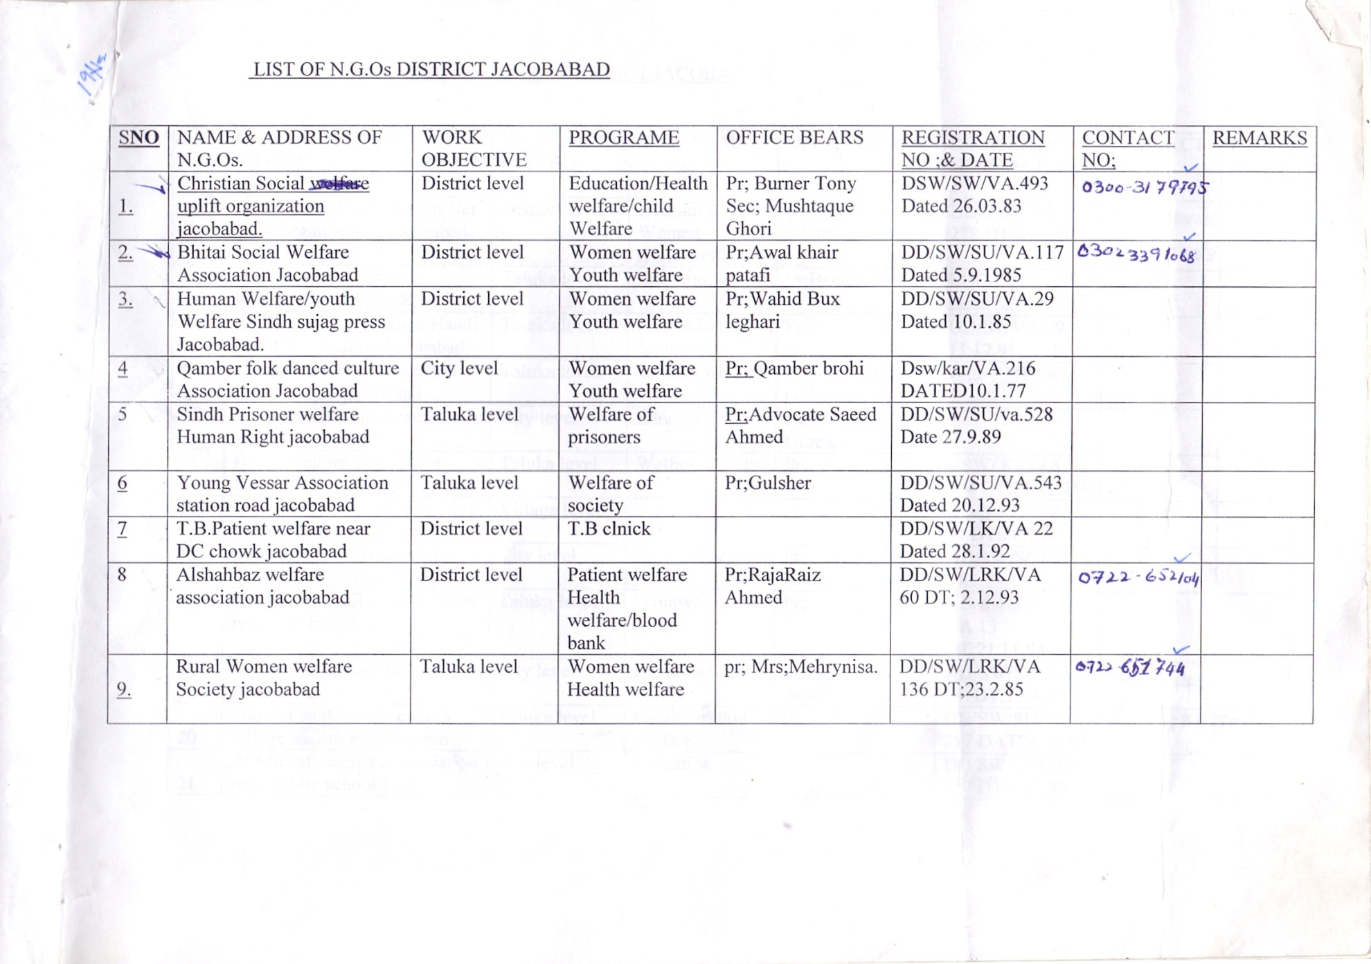
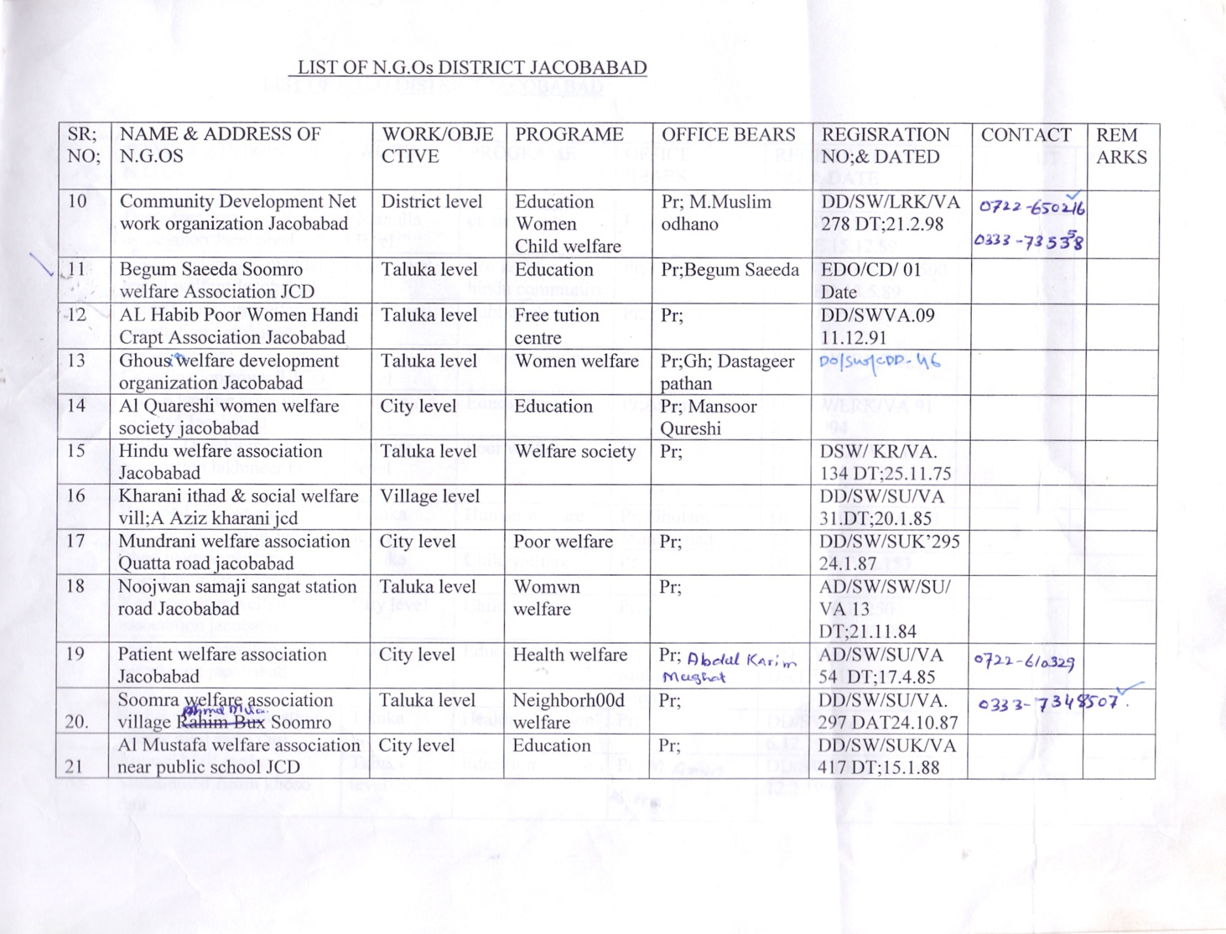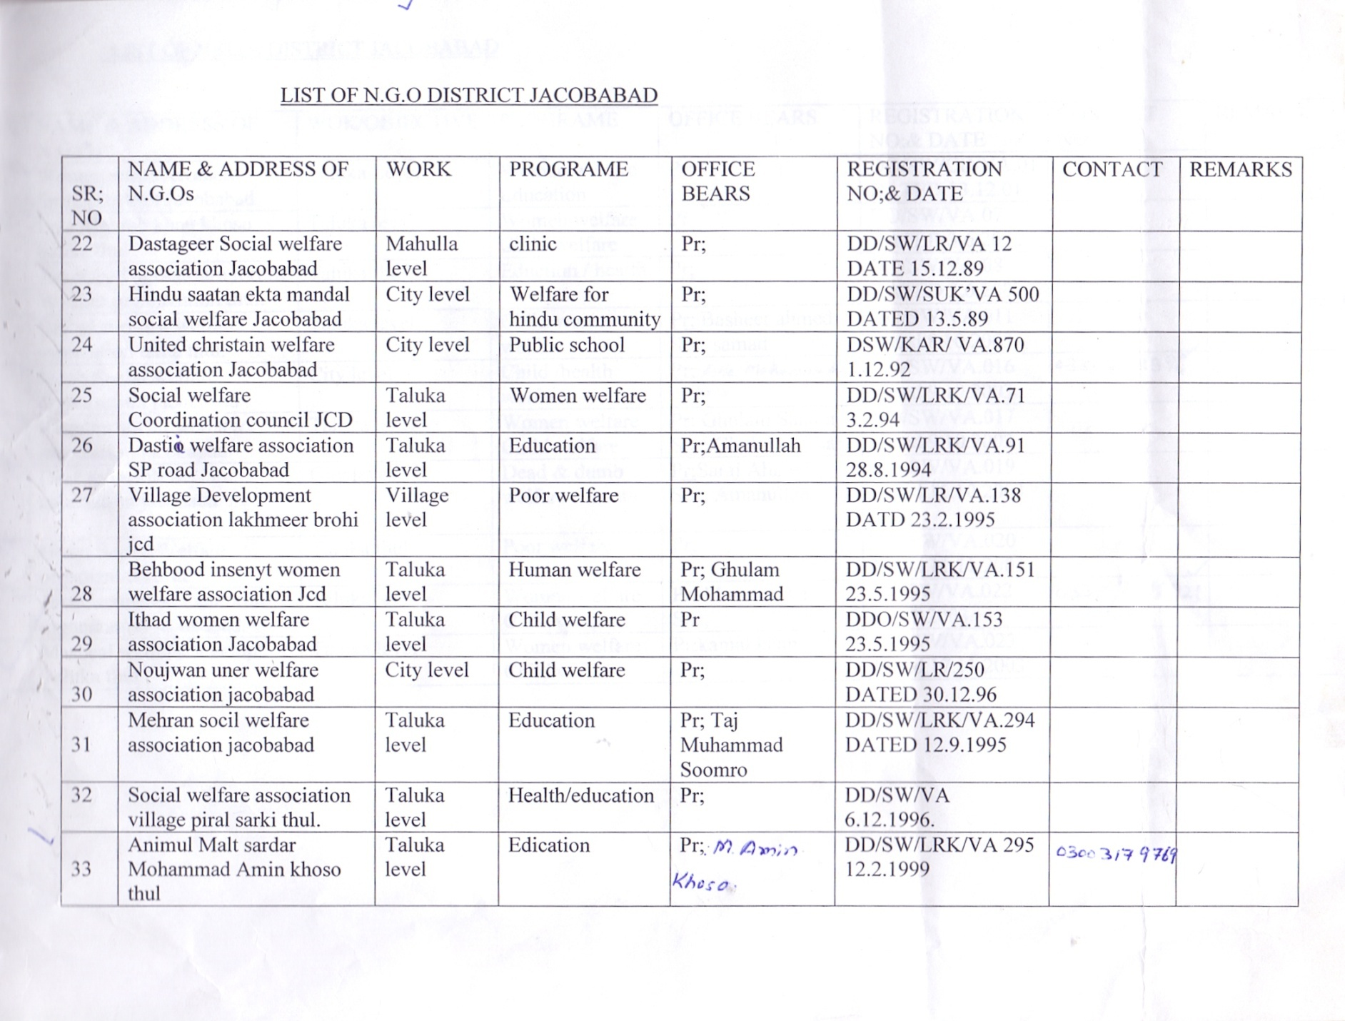
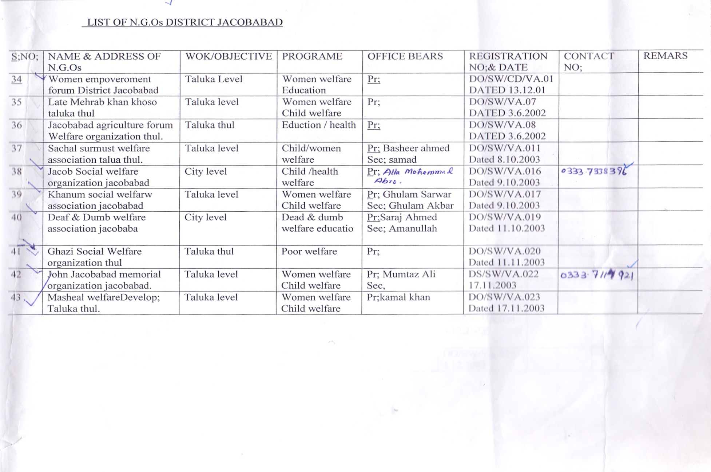

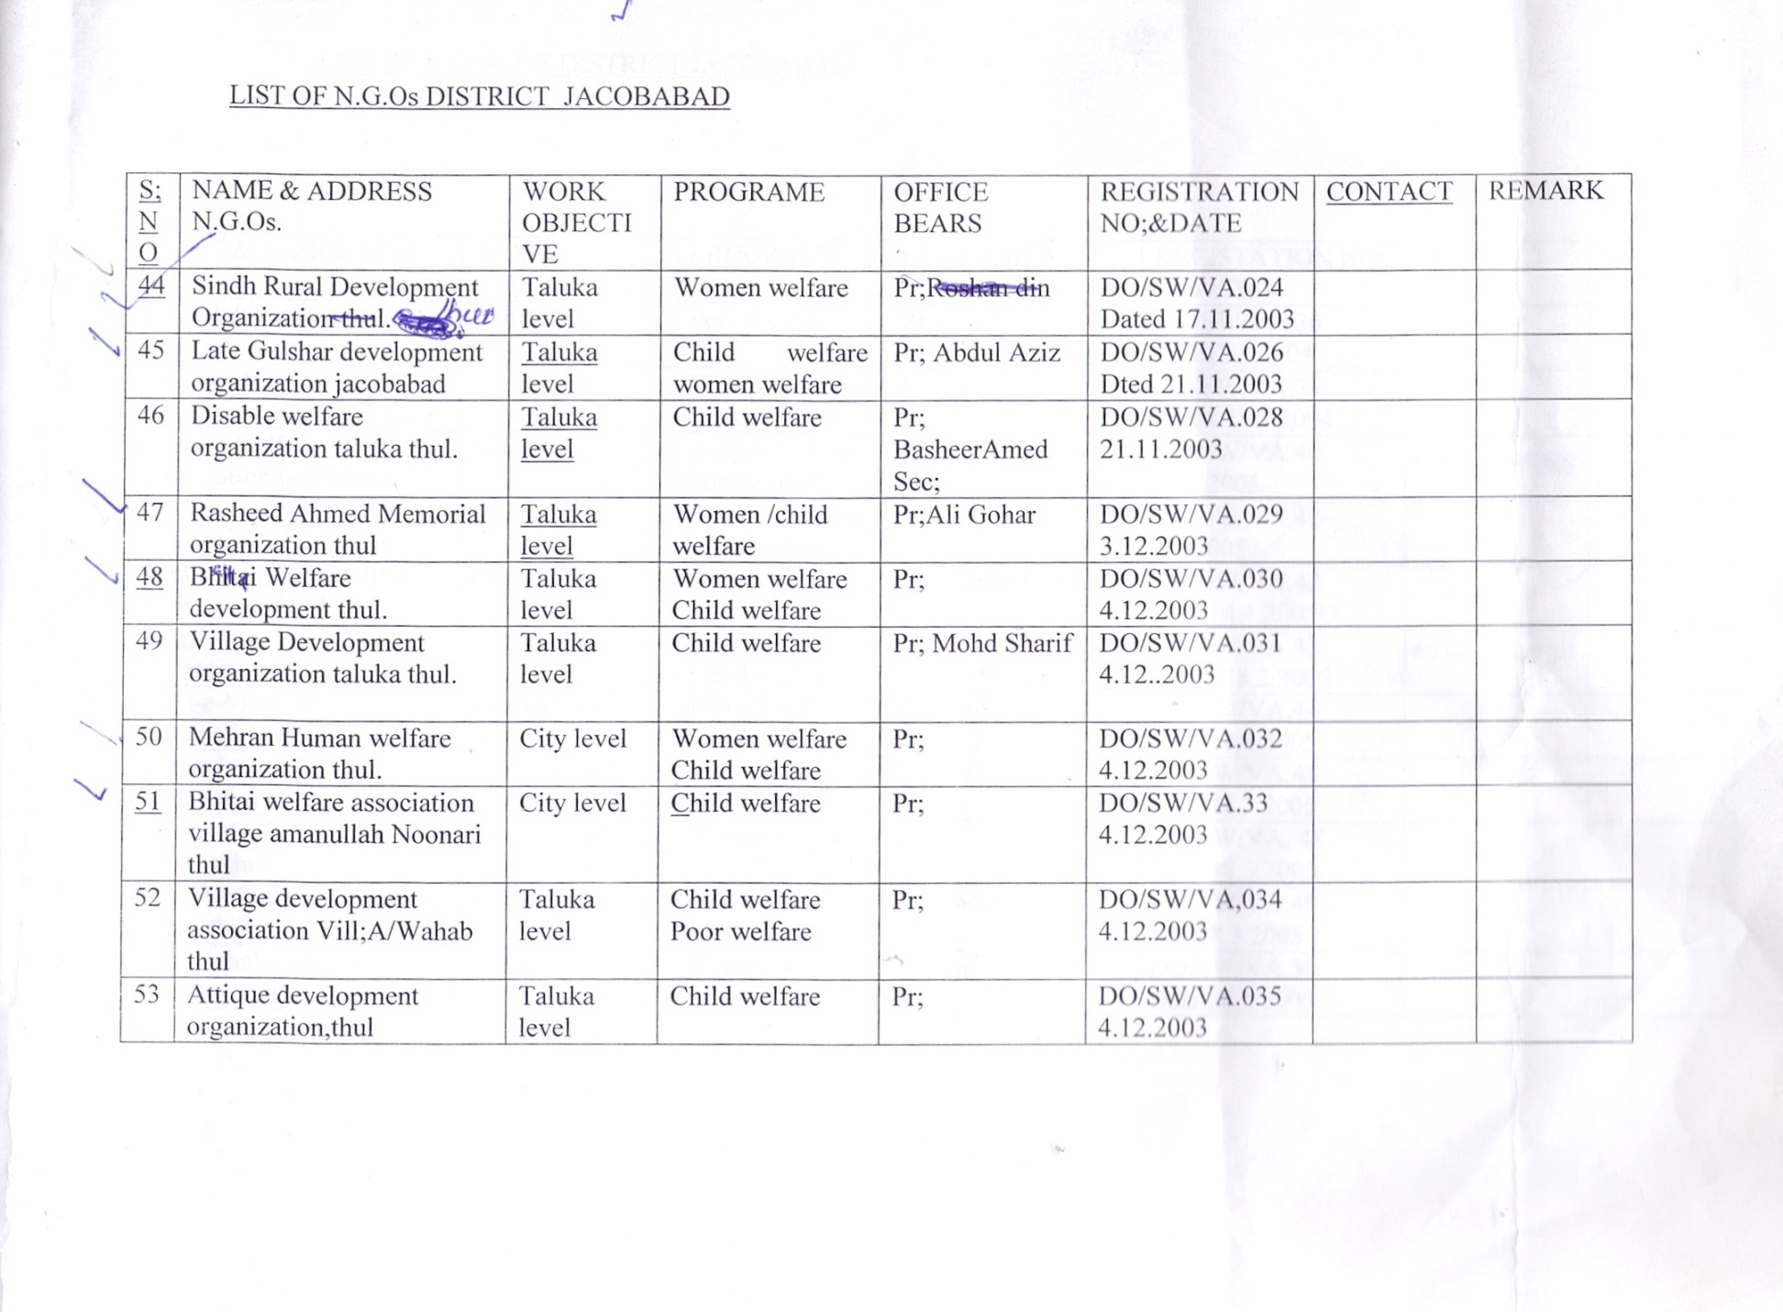
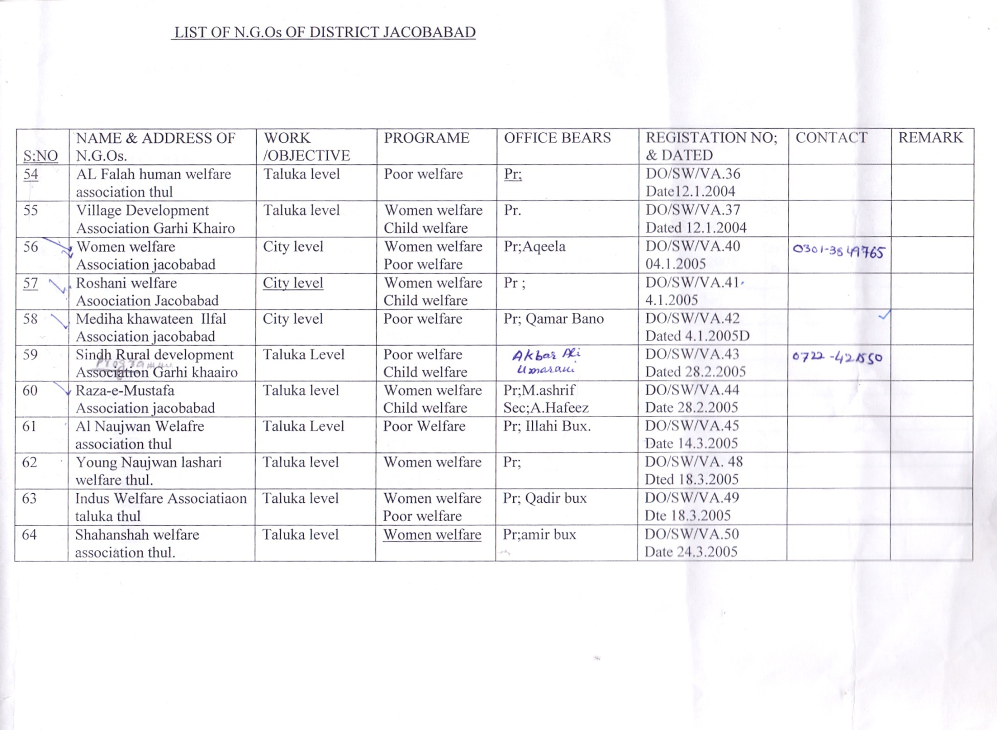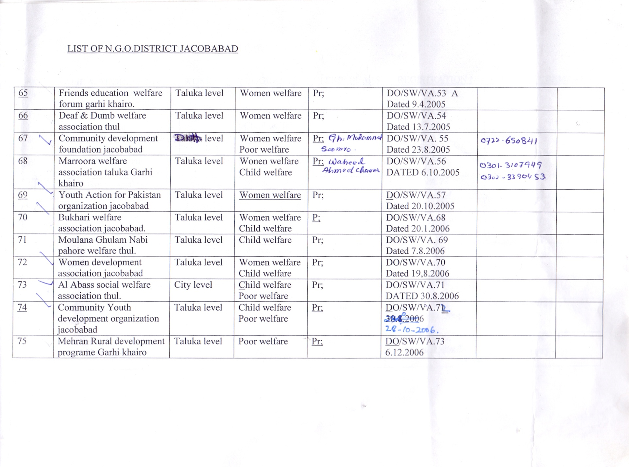
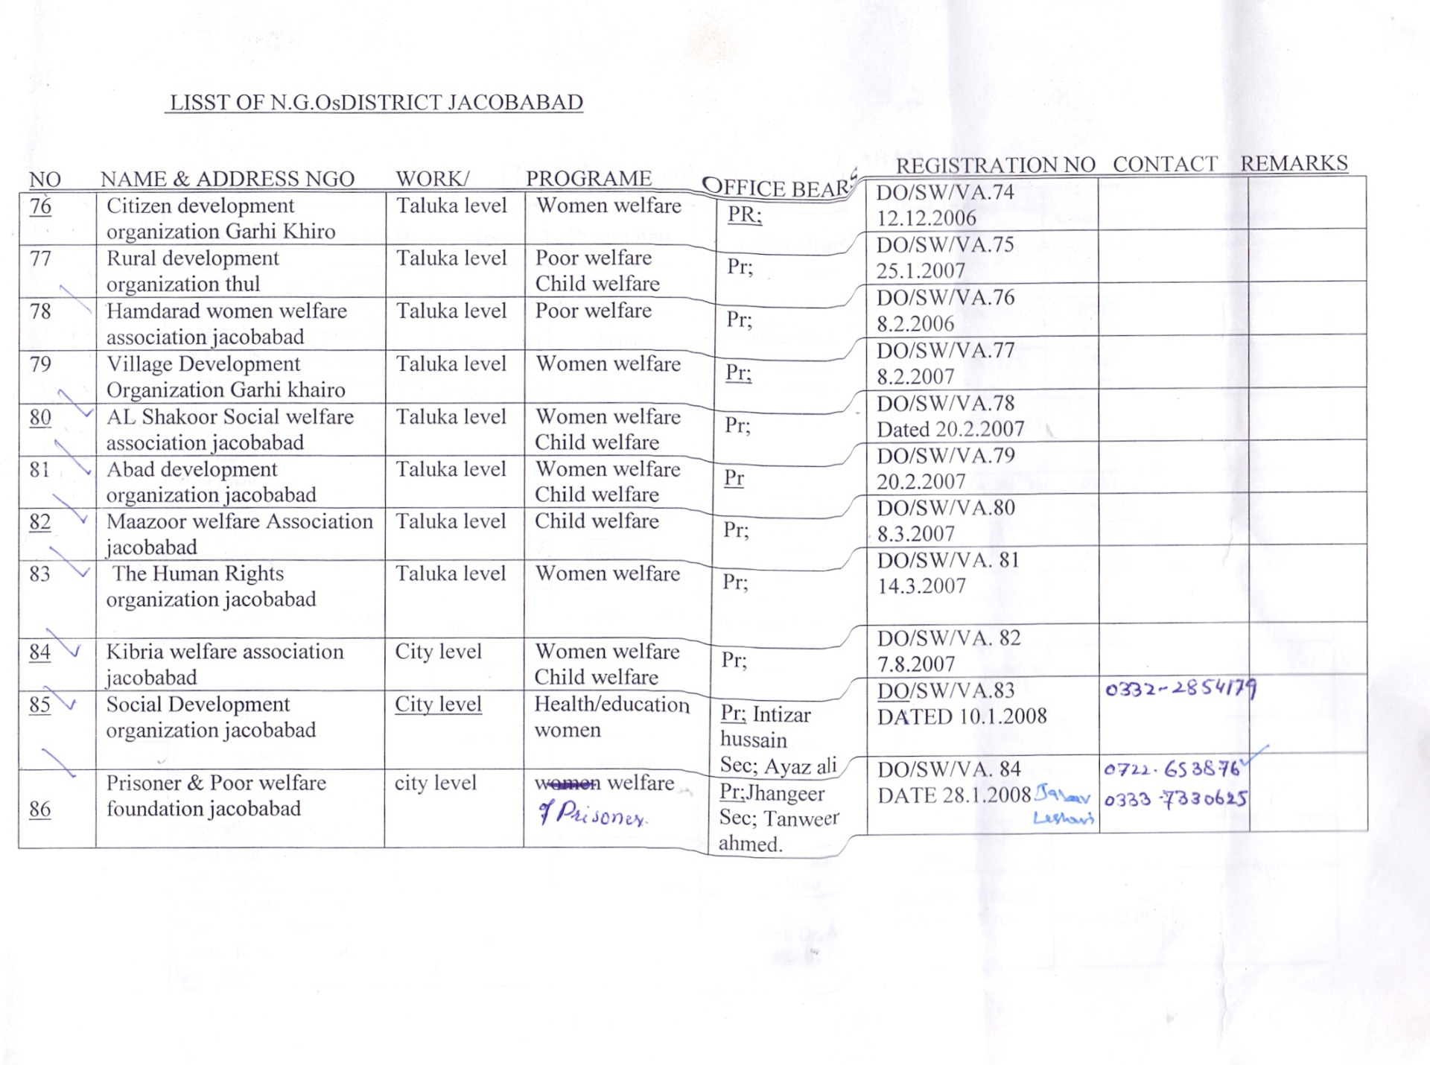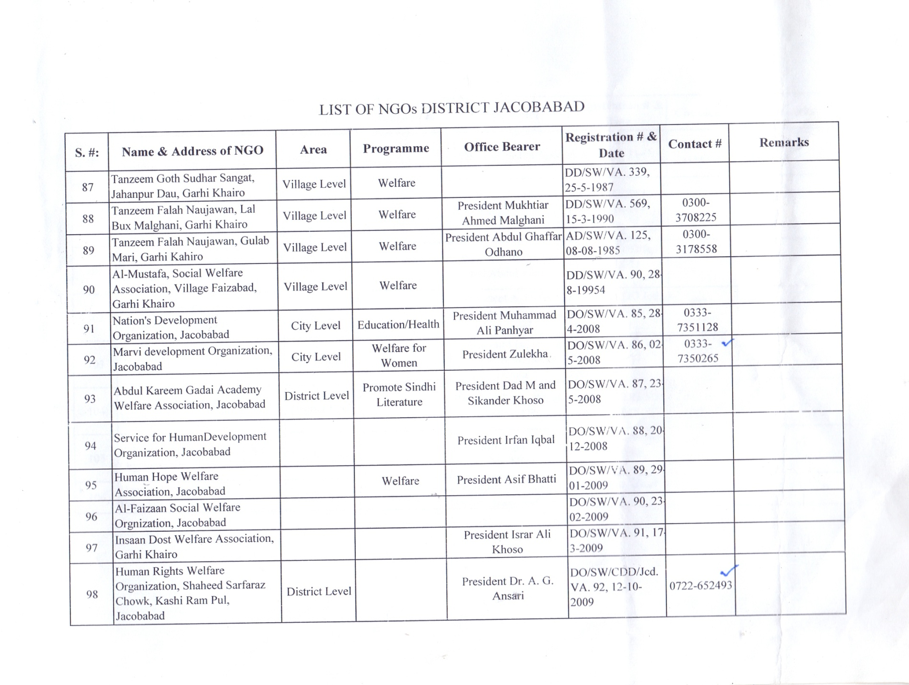
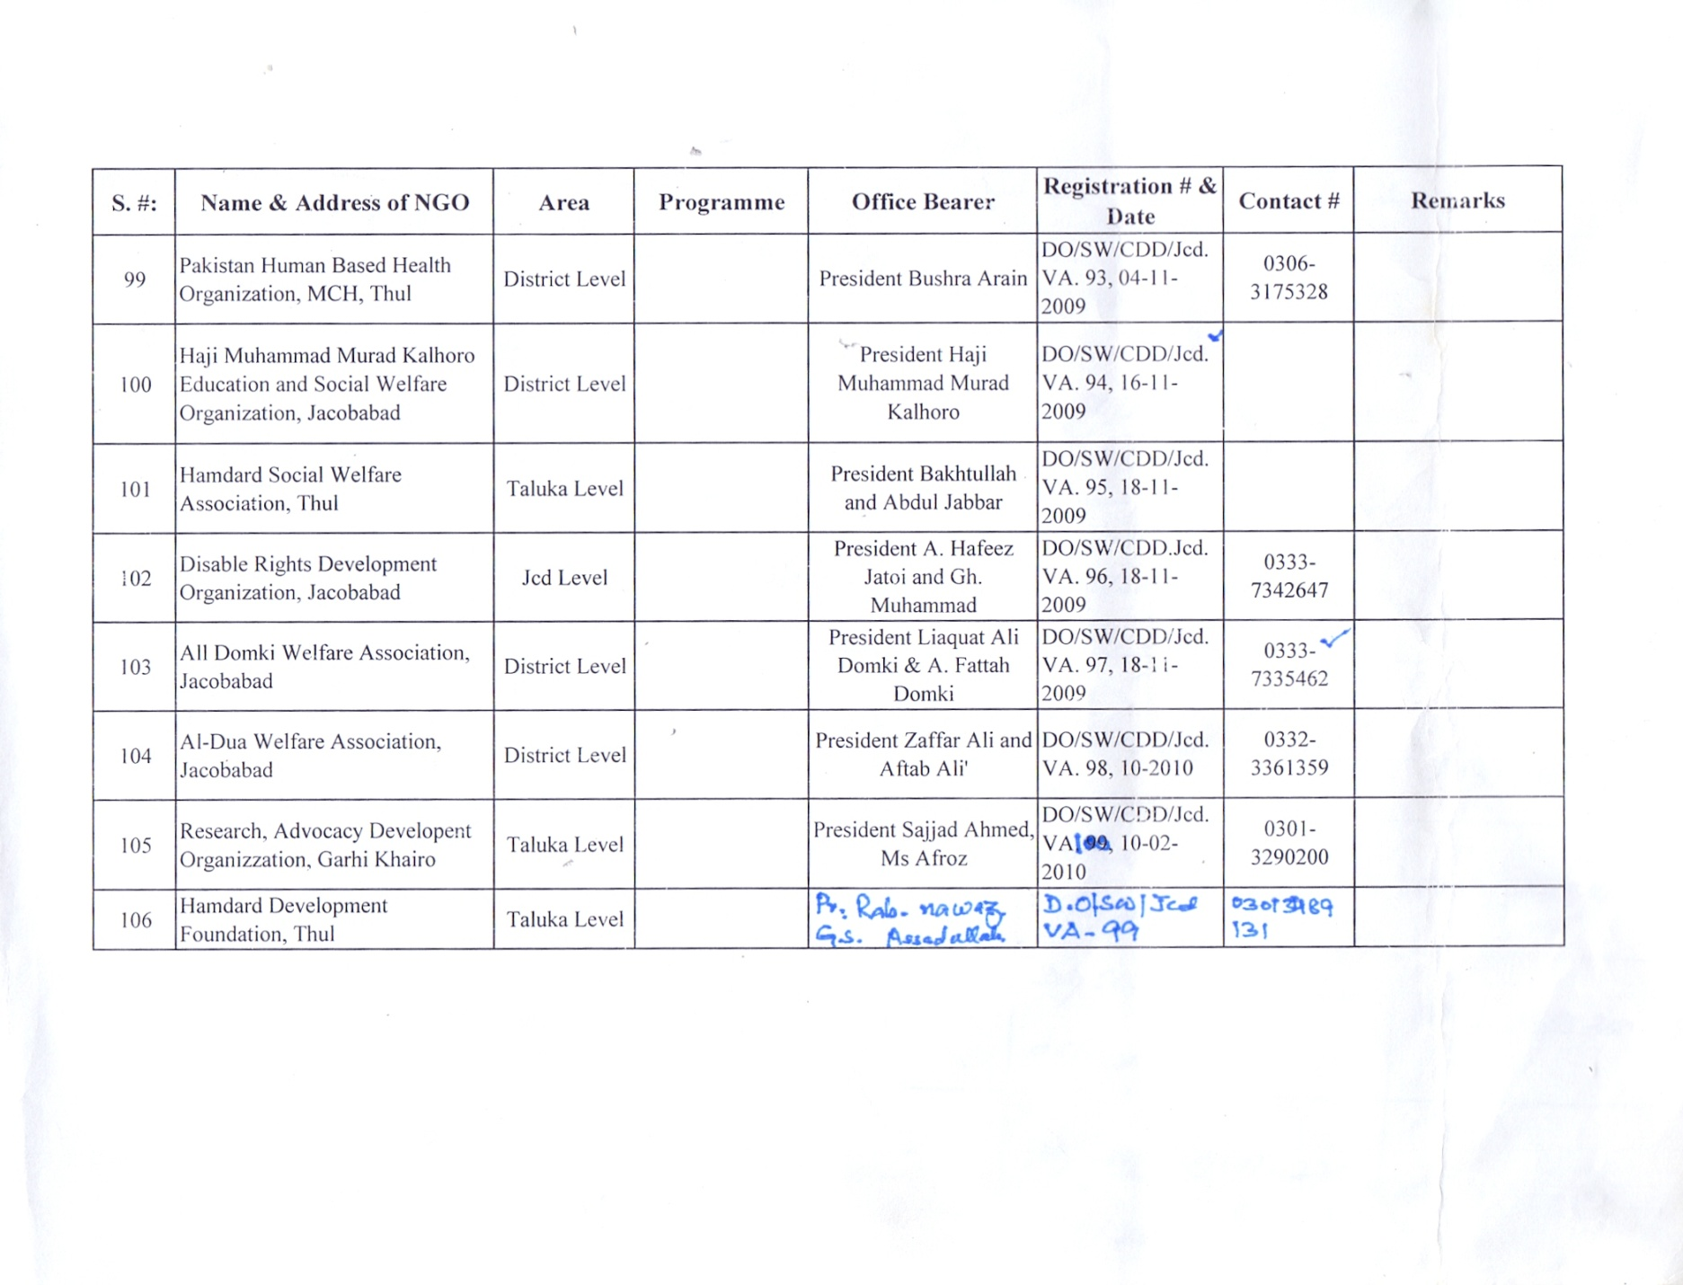
SNO | Name & Address of NGO | Office Bears | Registration No & Date | Contact No
107 | Pakistan Association of blind branch Jacobabad | PR Hasul Khan | DO/SW/JCD/VA 219 Date: 4-11-2011 | 0331-5837422
108 | Journalist Association Jacobabad | PR Haki Ali Aeri | DO/SW/JCD/VA 220 Date: 4-11-2011 | 0333-7341360
109 | Association for Nation Development | PR Syed Yasin Shah | DO/SW/JCD/VA 222 Date: 5-11-2011 | 0333-7901507
110 | United Action for Human Development Organization | PR M.Iqbal Naich | DO/SW/JCD/VA 223 Date: 5-11-2011 | 0300-3171314
111 | Citizen Association for National Development | PR Javed Ali | DO/SW/JCD/VA 224 Date: 5-11-2011 | 0344-3985300
112 | Ghalib e Sindh Faiz Buxapuri | PR Akhtiyar Ali Domki | DO/SW/JCD/VA 231 Date: 5-11-2011 | 0344-3130623
113 | Jhloy Lal Social Welfare Jacobabad | PR Sani Walvani | DO/SW/JCD/VA 233 Date: 5-11-2011 | 0300-7038105
114 | Asian Council for Human Rights Organization | PR Syed Pir Mhummad | DO/SW/JCD/VA 237 Date: 22-10-2012 | 0300-3225803
115 | Community Welfare & Development Organization | PR Mohummad Ibrahim | DO/SW/JCD/VA 239 Date: 26-11-2012 | Nil
116 | Innovative Social Research Association | PR Ali Asghar | DO/SW/JCD/VA 240 Date: 27-11-2012 | 0333-7350208
117 | Human Aid Focus The human Rights & Welfare Association | PR Wazir AHmed | DO/SW/JCD/VA 242 Date: 28-01-2013 | 0302-3392399
118 | Ithad Friends Welfare Forum for National Development | PR Profesor Wazir Lai Sarki | DO/SW/JCD/VA 244 Date: 25-06-2013 | 0300-2977276
119 | Faryad Childs & Women welfare Organization | PR Mrs.Sarfaraz | DO/SW/JCD/VA 245 Date: 5-9-2013 | 0308-3172890
120 | Women Empowerment & welfare Association | PR Khalida Parveen | DO/SW/JCD/VA 246 Date: 1-10-2013 | 0332-2771345
121 | Patient Welfare Association | PR Dr.Karin Bux Qasmi | DO/SW/JCD/VA 247  Date: 28-10-2013 | 0333-7104084
122 | Indus Participatory Development Organization | PR Ali Bux | DO/SW/JCD/VA 248 Date: 30-10-2013 | Nil
123 | Bright Women Welfare Association | PR Humra Khatoon | DO/SW/JCD/VA 249 Date: 27-01-2014 | Nil
124 | Sindh Education & Development Welfare Organization | PR Majid Ahmed | DO/SW/JCD/VA 250 Date: 27-01-2014 | 0333-7353949
125 | Helpers Welfare Association Thull | PR Zahoor Ahmed | DO/SW/JCD/VA 251 Date: 17-03-2014 | 0333-7337176
126 | Khushhal Sindh Welfare | PR Asghar Ali | DO/SW/JCD/VA 252 Date: 8-04-2014 | 0333-2457987
127 | Childs Protection Welfare Organization Thull | PR Shahjahan | DO/SW/JCD/VA 253 Date: 29-04-2014 | 0315-3465037
128 | Village Welfare Development Organization thull | PR GHulam Qadir | DO/SW/JCD/VA 254 Date: 29-04-2014 | 0315-3171171
129 | City Star Development Welfare Organization | PR Ayaz Ali | DO/SW/JCD/VA 255 Date: 29-04-2014 | 0333-7128243
130 | Women Children Welfare Association | PR Abdul Rasheed Khoso | DO/SW/JCD/VA 256 Date: 29-04-2014 | 0333-7351625
131 | Children Relief Service Organization | PR Nisar Ahmed | DO/SW/JCD/VA 257 Date: 2-05-2014 | 0333-7303475
132 | Mohummad Umar Kalwar Social Welfare Organization | PR M.Umar Kalwar | DO/SW/JCD/VA 258 Date: 2-05-2014 | 0333-7347242
133 | Shifa Welfare Association | PR Gul Buledi | DO/SW/JCD/VA 259 Date: 29-01-2015 | 0334-6051409
134 | Savera Development Organization Garhi Khairo | PR Ali Haider | DO/SW/JCD/VA 260 Date: 23-02-2015 | 0300-2548918

LIST OF NON FUNCTIONAL RIGESTRED NGOs DISTRICT JACOBABAD.
S NO | NAME OF NGO | NO AND  REGISTRED DATE | ADDRESS OF NGO | NAME OF OFFICE BAREARE
 | Women welfare association | Do/sw/jcd/va- 40  Dated 04-01-2005 | Near city police  Station Jacobabad | Mrs.aqeela
 | Pakistan association of blind branch Jacobabad | Do/sw/jcd/va-219  Dated 04-11-2011 | Shikarpur road  Jacobabad | Mr.hasul khan
 | Young nojawan lashari welfare association | Do/sw/jcd/va-48  Dated 18-03-2005 | Lashahri muhalla  thull | Mr.
 | Khanum social welfare association | Do/sw/jcd/va-17  Dated 09-10-2003 | Shikarpur road  Jacobabad | Mr.muhammad sarwar
 | Orgnaizaion for integrated development | Do/sw/jcd/va-164  Dated 29-09-2001 | Dakhan muhalla  Jacobabad | Mr.abdul latif soomro
 | Community welfare and development orgnaization | Do/sw/jcd/va-239  Dated 26-11-2012 | Jacobabad | Mr.muhammad ibrahim
 | United action for human development organization | Do/sw/jcd/va-223  Dated 05-11-2011 | Sahafi colony  Jacobabad | Mr.muhammad iqbal naich
 | Association for nation development | Do/sw/jcd/va-222  Dated 05-11-2011 | Gharibabad  jacobabad | Mr.syed yaseen ali shah
 | Jacob social welfare organization | Do/sw/jcd/va-16  Dated 09-10-2003 | Near imam  bargah Jacobabad | Mr.
 | Jhon Jacob memorial organization | Do/sw/jcd/va-22  Dated 17-11-2003 | Dho office  Jacobabad | Mr.mumtaz ali kanasro
 | Indus welfare association | Do/sw/jcd/va-49  Dated 18-03-2005 | Thull | Mr.
 | Allah rakhio welfare association | Do/sw/jcd/va-183  Dated 13-10-2011 | Thull | Mr.
 | Children relief organization | Do/sw/jcd/va-257  Dated 02-05-2014 | Jacobabad | Mr.
 | Jacobabad agriculture forum | Do/sw/jcd/va-08  Dated 03-06-2002 | Thull | Mr.
 | Galaxy welfare orgnaization | Do/sw/jcd/va-103  Dated 16-07-2010 | Near dolphin  baker jacobabad | Mr.ghulam ali
 | Behboob e insaniyat welfare orgnaization | Ad /sw/lrk/va-151  Dated 23-05-1995 |  | Mr.
 | Marvi development orgnaization | Do/sw/jcd/va-86  Dated 21-05-2008 | Near shah latif public school jacobabd | Mrs. Zulekhan
 | Syed ghulam sarwar bukhari welfare association | Do/sw/jcd/va-229  Dated 05-11-2011 | Vill ahmed mian soomro Jacobabad | Mr.abbas ali shah
 | Al abbas social welfare association | Do/sw/jcd/va-71  Dated 30-08-2006 | Thull | Mr.
 | Rural development welfare orgnaization | Do/sw/jcd/va-75  Dated 25-01-2007 | Garhi khairo | Mr.yar Muhammad jamali
 | Saleem welfare organization | Do/sw/jcd/va-149  Dated 11-07-2011 | Thull | Mr.muhammad Yahiya
 | Molana ghulam nabi pahore welfare association | Do/sw/jcd/va-69  Dated 07-08-2006 | Thull | Mr.ghulam nabi pahore
 | rural development organization | Do/sw/jcd/va-24  Dated 17-11-2003 | Thull | Mr.roshan deen
 | Shehanshah welfare association | Do/sw/jcd/va-50  Dated 18-03-2005 | Thull | Mr.ameer bux
 | Mehran social welfare association | Do/sw/lrk/va-294 |  | Mr.taj Muhammad soomro
 | Hamdarad social welfare association | Do/sw/jcd/va-95  Dated 18-11-2009 | Thull | Mr.abdul jabar
 | All domki welfare association | Do/sw/jcd/va-97  Datd 18-11-2009 | Jacobabad | Mr.abdul fateh domki
 | Tanzeem sangat sudhar jahan pur garhi khairo | Dd/sw/lrk/va-339 | Garhi khairo | Mr.
 | Innovative social research association | Do/sw/jcd/va-240  Dated 27-11-2012 | Near district council office Jacobabad | Mr.ali asghar
 | Ghousia welfare association | Do/sw/jcd/va-46  Dated | Apposite palace hotel Jacobabad | Mr.ghulam dastageer pathan
 | Sachal sarmast welfare association | Do/sw/jcd/va-11  Dated 08-10-2003 | Thull | Mr.basheer ahmed
 | Vill development association | Do/sw/jcd/va-34  Dated 04-12-2003 | Thull | Mr.abdul wahab
 | Muhammad bux nindwani welfare orgnaization | Do/sw/jcd/va-127  Dated 25-05-2011 | Thull | Mr.khadim hussain nindwani
 | Bagan burrioro welfare association | Do/sw/jcd/va-125  Dated 25-05-2011 | Thull | Mr.muhammad hayat burriro
 | Zarak khan brohi welfare organization | Do/sw/jcd/va-130  Dated 28-05-2011 | Vill zarak brohi  thull | Mr.gul hasan khan
 | Muhammad ibrahim welfare association | Do/sw/jcd/va-128  Dated 26-05-2011 | Thull | Mr.naeemullah burriro
 | Al madina social welfare association | Do/sw/jcd/va-133  Dated 01-06-2011 | Thull | Mr.fida hussain
 | Old people welfare association | Do/sw/jcd/va-144  Dated 11-07-2011 | Thull | Mr.wazir ahmed
 | Abdul aziz khan welfare association | Do/sw/jcd/va-137  Dated 15-06-2011 | Jacobabad | Mr.qadir bux
 | Jamali welfare association | Do/sw/jcd/va-145  Dated 11-07-2011 | Dastageer colony  Jacobabad | Mr.abdul waheed jamali
 | Islami welfare association | Do/sw/jcd/va-163  Dated 27-09-2011 | Thull | Mr.arz Muhammad
 | Tb patient welfare association | Dd/sw/lrk/va-22  Dated 02-12-1992 | Near kashti chowk  jacobabad | Mr.dr gul Muhammad burriro
 | Human welfare association | Do/sw/jcd/va-29  Dated 01-01-1985 | Near mukhtiarkar  Office Jacobabad | Nill
 | Bhittai social welfare association jcd | Ad /sw/suk/va-117  Dated 05-09-1985 | Near civil hospital  Jacobabad | Mr.awal khair pitafi
 | Young veesar association | Dd/sw/sukk/va-543  Dated 20-12-1989 | Station road  jacobabad | Mr.rafiqe veesar
 | Tanzeem falah nojawan | Dd/sw/lrk/va-569  Dated 15-03-1991 | Garhi khairo | Nill
 | Allah abad machi social welfare association | Do/sw/jcd/va-114  Dated 02-05-2011 | Jacobabad | Mr.gul hasan
 | Abdul majeed hambhi social welfare association | Do/sw/jcd/va-113  Dated 18-04-2011 | Jacobabad | Mr.noor ahmed hambhi
 | Al shahbaz welfare association | Dd/sw/lrk/va-60  Dated 02-12-1993 | Jacobabd | Mr.raja riyaz
 | Haji Muhammad murad kalohro education &social welfare orgnaization | Do/sw/jcd/va-94  Dated 16-04-2009 | jacobabad | Mr.rashid ahmed kalhoro
 | Research advocacy development orgnaization | Do/sw/jcd/va-100  Dated 10-02-2011 | Garhi khairo | Mr.sajjad ahmed
 | Al Mustafa social welfare association | fdd/sw/lrk/va-90  Dated 28-08-1995 | Garhi khairo | Mr.
 | Women empowerment forum | Do/sw/jcd/va-01  Dated 13-12-2001 | Jacobabad | Mrs aisha khoso
 | Servicefor women development organization | Do/sw/jcd/va-88  Dated 20-12-2008 | Jacobabad | Mr.irfan iqbal
 | Al faizan social welfare organization | Do/sw/jcd/va-90  Dated 23-02-2009 | jacobabad | Mr.abdul majeed burriro
 | Mulan sodho welfare association | Do/sw/jcd/va-131  Dated 31-05-2011 | Thull | Mr.
 | Peer juman shah jelani welfare orgnaization | Do/sw/jcd/va-132  Dated 01-06-2011 | Vill juman shah  Jeelani thull | Mr.shahal khan
 | Mashal welfare development | Do/sw/jcd/va-23  Dated 17-11-2003 | Thull | Mr.kamal khan
 | Disable welfare organization | Do/sw/jcd/va-28  Dated 21-11-2003 | Thull | Mr.basheer ahmed
 | Asian council for human rights orgnaization | Do/sw/jcd/va-237  Dated 22-10-2012 | Jacobabd | Mr.peer Muhammad shah
 | Bhittai welfare development organization | Do/sw/jcd/va-30  Dated 04-12-2003 | Thull | Mr. shah Muhammad noonari
 | Jhooly lal social welfare organization | Do/sw/jcd/va-233  Dated 05-11-2011 | Danger muhalla  Jacobabad | Mr.sunny walwani
 | Ghalib e sindh faiz bakshapuri welfare association | Do/sw/jcd/va-231  Dated 05-11-2011 | Jacobabad | Mr.akhtiar ali domki
 | Late mehrab khan khoso welfare association | Do/sw/jcd/va-07  Dated 03-06-2002 | Thull | Mr.muhammad sharif khoso
 | Safe social welfare organization | Do/sw/jcd/va-236  Dated 20-09-2012 | Thull | Mr.wasim saif khoso
 | Masuad welfare association | Do/sw/jcd/va-221  Dated 04-11-2011 | Thull | Mr.zulfiqar ali
 | Education development welfare organization | Do/sw/jcd/va-235  Dated 07-07-2011 | Thull | Mrs sabira
 | Save the human and development organization | Do/sw/jcd/va-238  Dated 07-11-2012 | Thull | Mr.dr munir ahmed soomro
 | Vill welfare development organization | Do/sw/jcd/va-254  Dated 29-04-2014 | Thull | Mr.ghulam qadir
 | Sindhri welfare organization | Do/sw/jcd/va-241  Dated 28-01-2013 | Jacobabad | Mr.waheed ali brohi
 | Ghazi social welfare association | Do/sw/jcd/va-20  Dated 11-11-2003 | Thull | Mr.ghulam hussain
 | Al falah human welfare association | Do/sw/jcd/va-36  Dated 12-01-2004 | Thull | Nill
 | Citizen association for national development | Do/sw/jcd/va-224  Dated 05-11-2011 | Gharibabad Jacobabad | Mr.zahid ali rind
 | Attique development organization | Do/sw/jcd/va-35  Dated 04-12-2003 | Thull | Nill
 | Mehran human social welfare organization | Do/sw/jcd/va-32  Dated 04-12-2003 | Thull | Nill
 | Social welfare association | Dd/sw/jcd/va  Dated 06-12-1996 | Thull | Nill
 | All nojawan welfare association | Do/sw/jcd/va-45  Dated 14-03-2005 | Thull | Nill
 | Roshni social welfare association | Do/sw/jcd/va-41  Dated 04-01-2005 | Jacobabad | Mr.abdul fareh domki
 | Marrura welfare association | Do/sw/jcd/va-56  Dated 06-10-2005 | Garhi khairo | Mr.faiz Muhammad
 | Kibria welfare association | Do/sw/jcd/va-82  Dated 07-08-2007 | Jacobabad | Nill
 | Abad development organization | Do/sw/jcd/va-79  Dated 20-02-2007 | Jacobabad | Nill
 | Sastainable intivatvi for development association | Do/sw/jcd/va-82a  Dated 07-08-2007 | Thull | Mr.faheem abbasi
 | Sindh rural welfare organization | Do/sw/jcd/va-116  Dated 07-05-2011 | Jacobabad | Mr.muhammad imran
 | Gous bux jatoi social welfare organization | Do/sw/jcd/va-115  Dated 05-05-2011 | Jacobabad | Mr.muhammad yousif
 | Bhanger social welfare organization | Do/sw/jcd/va-123  Dated 24-05-2011 | Jacobabad | Mr.mushtaq ahmed
 | Gul Muhammad social welfare organization | Do/sw/jcd/va-124  Dated 24-05-2011 | Jacobabad | Mr.ghulam qadir
 | Haji Muhammad athar welfare association | Do/sw/jcd/va-129  Dated 26-05-2011 | Jacobabad | Mr.haji Muhammad athar
 | Sojhro khan umrani development welfare organization | Do/sw/jcd/va-126  Dated 25-05-2011 | Jacobabad | Mr.muhammad iqbal umrani
 | Young social welfare association | Do/sw/jcd/va-135  Dated 14-06-2011 | Jacobabad | Mr.muhammad rafiq brohi

Information about the NGOs District Jacobabad.

S.NO | NAME OF ACTIVE NGO WITH ADDRESS | AUDIT REPORT 2014-15 | BANK ACCOUNT | SOURCE OF FUNDING 2014-15
1 | Community Development Foundation Near TCF School Jcd | YES | MUSLIM COMMERCIAL BANK JCD.A/C 100-7828-7 | Asia Foundation
2 | Peace By Youth Welfare Organization Near Royal College Jcd | YES | NIB SUKKUR A/C 1253533977 | Alif Ailan
3 | Shifa Welfare Association First Family Line Jcd | NEW | NIL | NIL
4 | Nek Mohummad Khan Odho Social Welfare Association Village Mohd Pur Odho Jcd | YES | NIL | Individual
5 | Reformist Social Welfare & Development Organization Near Dargah Jeal Shah Bolan Jcd | YES | 000717900264503 | Project with BBSYDP
6 | Sharing Hands Organization Near Victor Public School Jcd. | YES | HABIB BANK LIMITED SUKKUR.A/C 00827900224411 | Individual Donors
7 | Christen Social Uplift Organization First Family Line Near Victor Public School Jcd | YES | AILIED BANK LIMITED JCD.A/C( 0119) | Income Generation Project
8 | Community Advanced & Support Welfare Association Near Masjid Quba Family Line Jcd | YES | THE FIRST WOMEN BANK LIMITED JCD.A/C 0333-101-738797-732336 | BBSYDP
9 | Sindh Educational Welfare Development ZABEST Public School Jcd | YES | NIL | Individual
10 | Youth Action For Pakistan Organization Behind Royal College Jcd. | YES | United Bank Limited JCD. A/C1010041105 | United Nation
11 | Community Development Network Organization Near Mairaj Hotel Jcd | YES | MUSLIM COMMERCIAL BANK JCD.A/C 7976-6  MICRO FINANCE JCD.A/C 3261-5 | BBSYDP-PMYSTP
12 | Savera Development Organization Shahi Bazar Garhi Khairo | YES | NIL | Individual
13 | Hamdarad Development Foundation Near Press Club Thul | YES | NIL | NIL

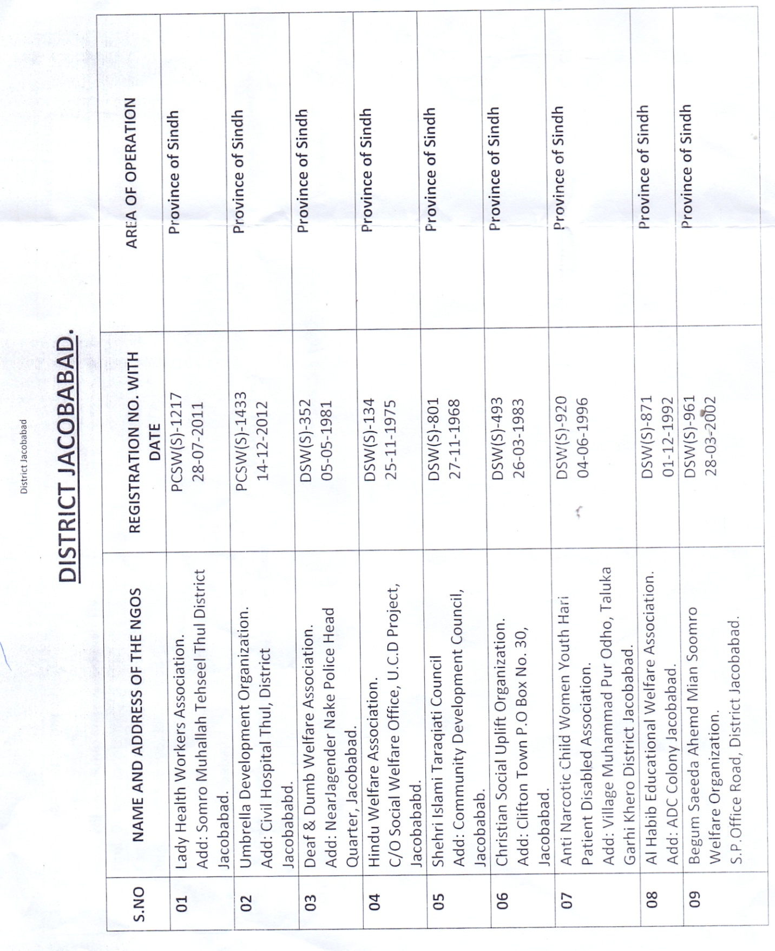
Functional
Non Functional
Functional
Functional/Non Functional

Non Functional

Non Functional
Functional

Non Functional
Non Functional
Non Functional

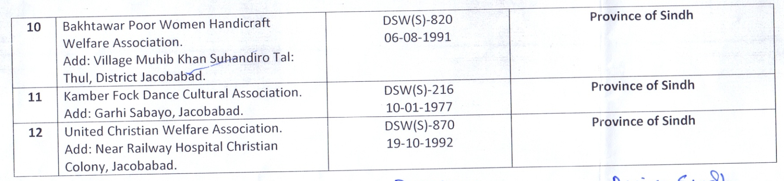
Non Functional
Non Functional

13 | Reformist Social Welfare Development Organization | Pcws/202 | Provincial | Functional
14 | Sharing Hands | Pcsw(s)/1098 | Provincial | Functional

